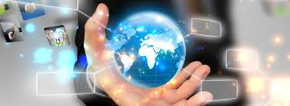

1. The world is in our hands.

2. We are creating the destiny of the planet.

3. The tecnology is connecting people.

4. The news is in our hands.

5. Technology is more and more in our lives.

6. The world is connected to information information.

7. The world is developing with technology.

8. People are in charge of the information.

9. People are changing the future of the world with tecnology.

10. The future is in information.

11. With the tecnology there are insurging cyber attacks.

12. A new view of the world is emerging.

13. We are using technology to change the world.